TECHNICAL PROJECT REPORT

# Title of Invention / Project:

REAL-TIME FEEDBACK SYSTEM FOR RESTAURANTS AND HOTELS

# Team Members / Inventors:

|  |  |  |  |  |  |
| --- | --- | --- | --- | --- | --- |
| **S. No.** | **Name** | **Department** | **Designation** | **Mobile** | **E-Mail** |
| 1. | Gauraksh Garg | CSE-MC | Student | 7696759415 | [gaurakshgarg123@gmail.com](mailto:gaurakshgarg123@gmail.com) |
| 2. | Vishwajeet Guleria | CSE-MC | Student | 7973042836 | [vishuguleria01@gmail.com](mailto:vishuguleria01@gmail.com) |
| 3. | Gaurav Yadav | CSE-MC | Student | 8360292501 | [gauravy2611@gmail.com](mailto:gauravy2611@gmail.com) |
| 4. | Rahul Gupta | CSE-MC | Student | 9813706791 | [gupta999.ra@gmail.com](mailto:gupta999.ra@gmail.com) |
| 5. | Khushal Thakur | ECE | Mentor | 9646030764 | [khushal.thakur@cumail.in](mailto:khushal.thakur@cumail.in) |
| 6. | Anshul Sharma | ECE | Mentor | 9478697475 | [anshulsharma.ece@cumail.in](mailto:anshulsharma.ece@cumail.in) |
| 7. | Kiran Jot Singh | ECE | Mentor | 9463909689 | [kiranjotsingh.ece@cumal.in](mailto:kiranjotsingh.ece@cumal.in) |
| 8. | Divneet Singh Kapoor | ECE | Mentor | 9878422653 | [divneet.ece@cumail.in](mailto:divneet.ece@cumail.in) |

Section – 1 (IPR Related)

# Brief Abstract:

Being in restaurants is so much fuzzy these days. Calling the waiter, giving the order, waiting for it, having the food, the sweet dish and then paying the bill and leaving. But in this whole process we forget one thing, what about rating the food? We don’t rate the food and the service we get. And this results in not getting the best of the food you are having or you are going to get on your next order or the next time. Have you ever thought of that? We thought this and just to solve this problem we thought of making this “Real-Time FeedBack System” for the restaurants that want to interact and improve their services for the customers and for those customers who want their order to be the best they had served to them at that time.

The main reasons for the need of a FeedBack System are:

* Customer feedback helps to improve products and services.
* Customer feedback helps you measure Customer Satisfaction.
* Collecting Customer feedback shows you value their opinion.
* Customer feedback helps you create the best customer experience.
* Customer feedback helps to improve customer retention.
* Customer feedback is a reliable source of information to other consumers.
* Customer feedback gives you data that helps taking business decisions.

Whenever a customer is giving the feedback they expect to get improved services.

The FeedBack System is consisting of a interfacing system placed on the table the customer is sitting which takes the valuable input from the customer and provides the output on the output screen placed near the owner or the manager which will take in consideration of the input given by the customer so as to improve their services.

# Existing state-of-the-art and Drawbacks in existing state-of-the-art

|  |  |  |
| --- | --- | --- |
| **S. No.** | **Existing state of art** | **Drawbacks in existing state of art** |
| 1 | Restaurants use booklets to get feedback from their customers | They do not have any digital data and they can’t compare the data with the entries on various basis |
| 2 | REAL-TIME CLIENT SURVEY SYSTEMS AND METHODS  (Patent No:- US007609832B2 Date of Patent: Oct. 27, 2009) | This is not appropriate for the field which we designed our system for. |

# Novel/Additional modifications that you can propose to improve upon drawbacks

* Digitalising the feedback for better analysis and results.
* Helps to improve the owner-customer relationship.

# Advantages

* Customer can report in Real-time to the owner.
* Transparent interfacing happens between customer and owner.
* Digitalising the feedback for better analysis and results

# Block Diagram

Section – 2 (Real Project)

# Materials

ARDUINO GENUINO UNO, LIQUID CRYSTAL DISPLAY 16*2, 4*4 KEYPAD, BREADBOARD, TERMINAL WIRES, RESISTORS-1K OHM,

CIRCUIT DIAGRAM:

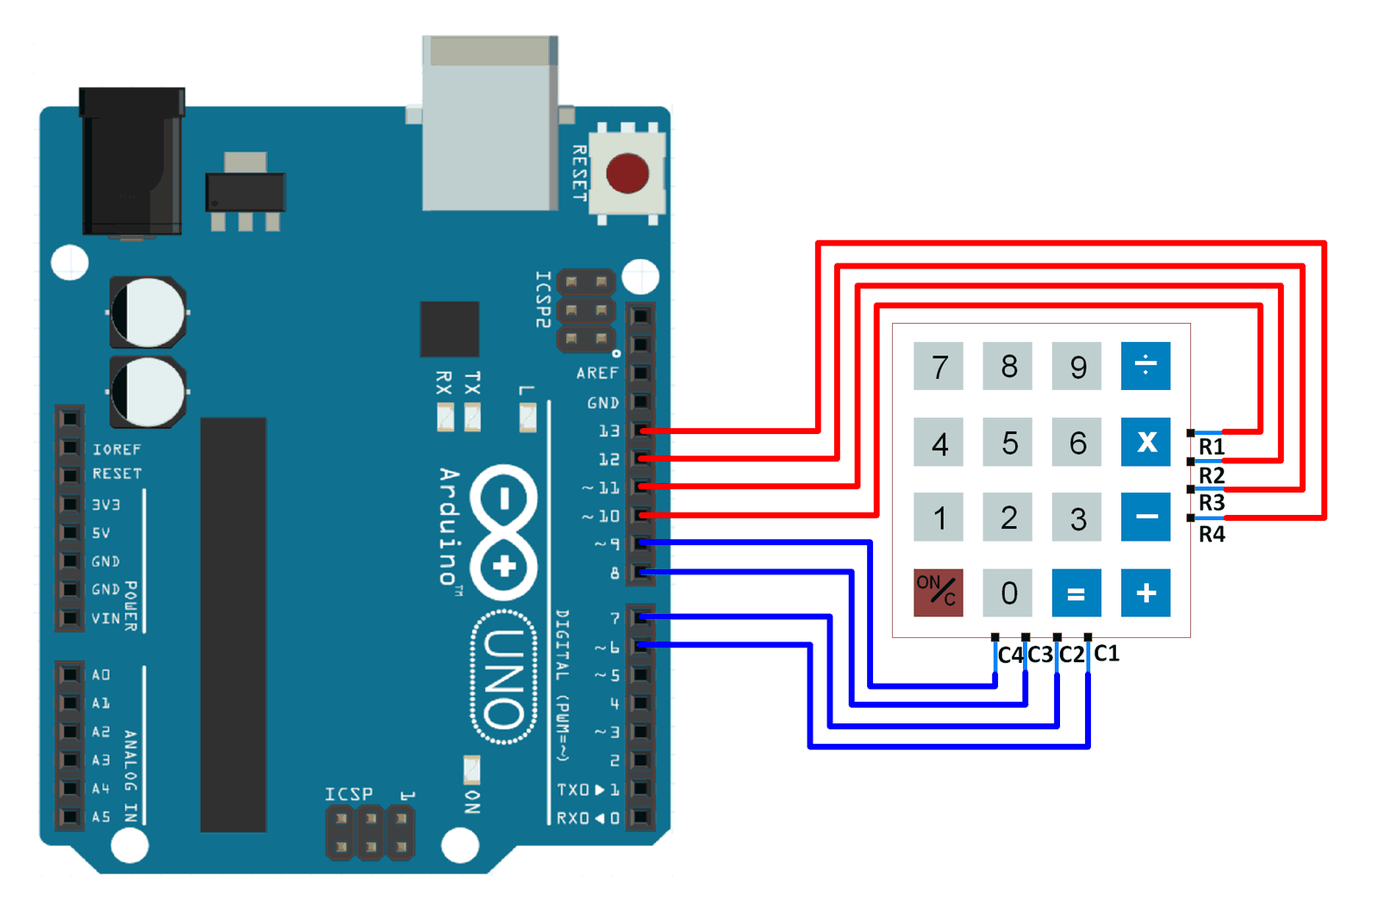

# Steps of Circuit Completion

First we have to interface LCD with Arduino board. Connecting the LCD with Arduino with the help of terminal wires, connecting them to digital pins on Arduino board and grounding the pins on the LCD.

Then we will interface keypad with Arduino using breadboard. We will connect the row and column pins to the Arduino. The interfacing is complete. Now we will upload the Program Code using “ARDUINO IDE”.

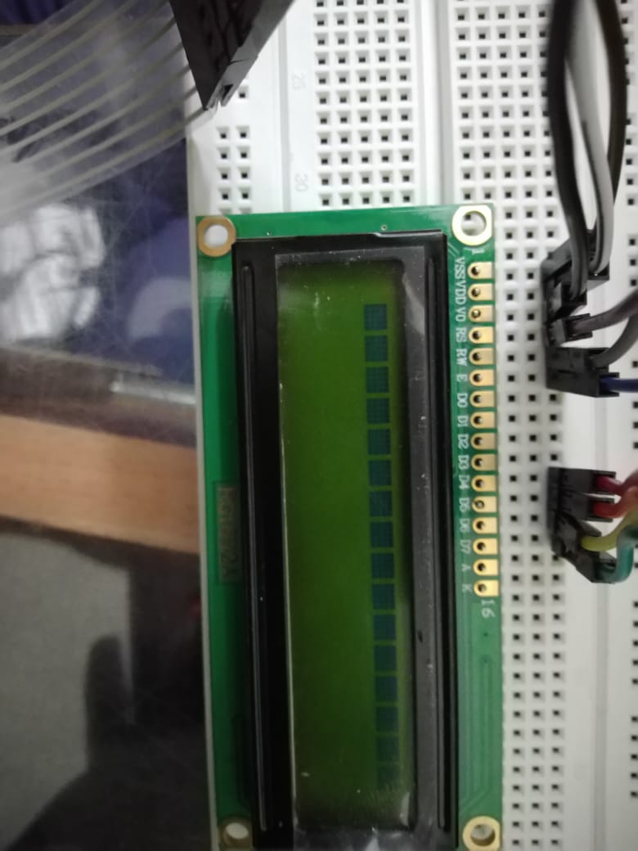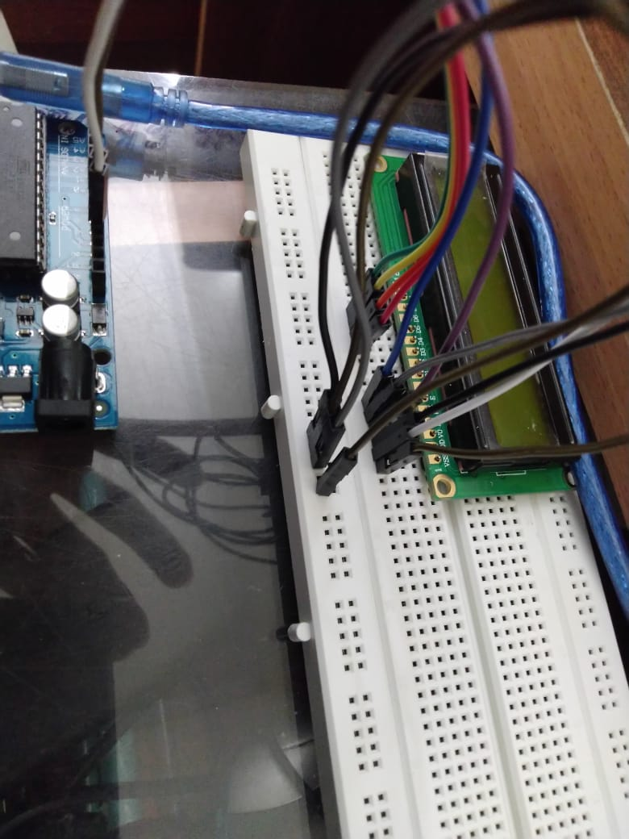

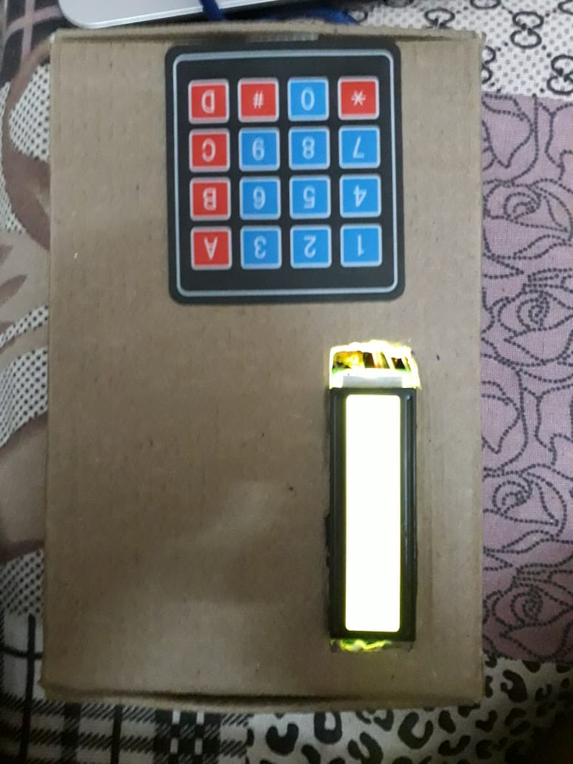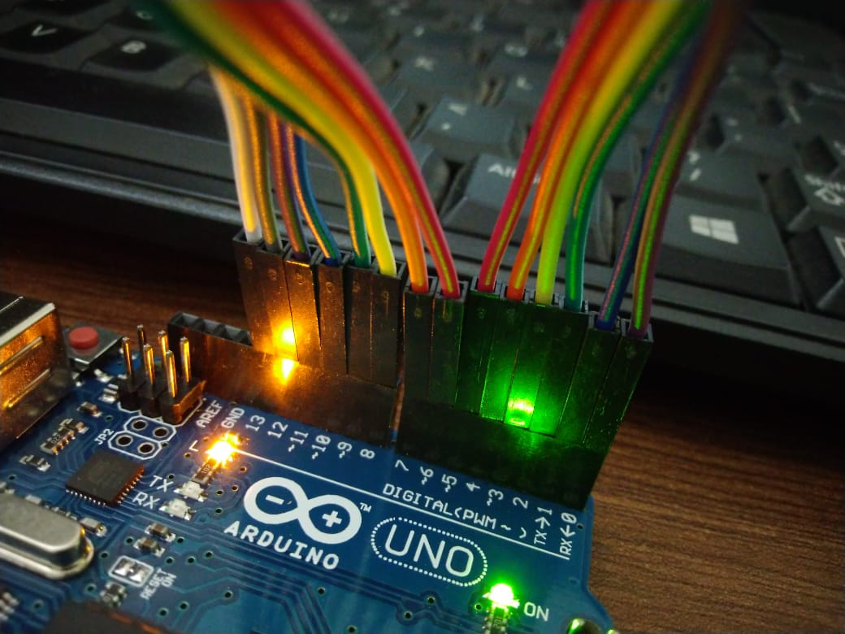

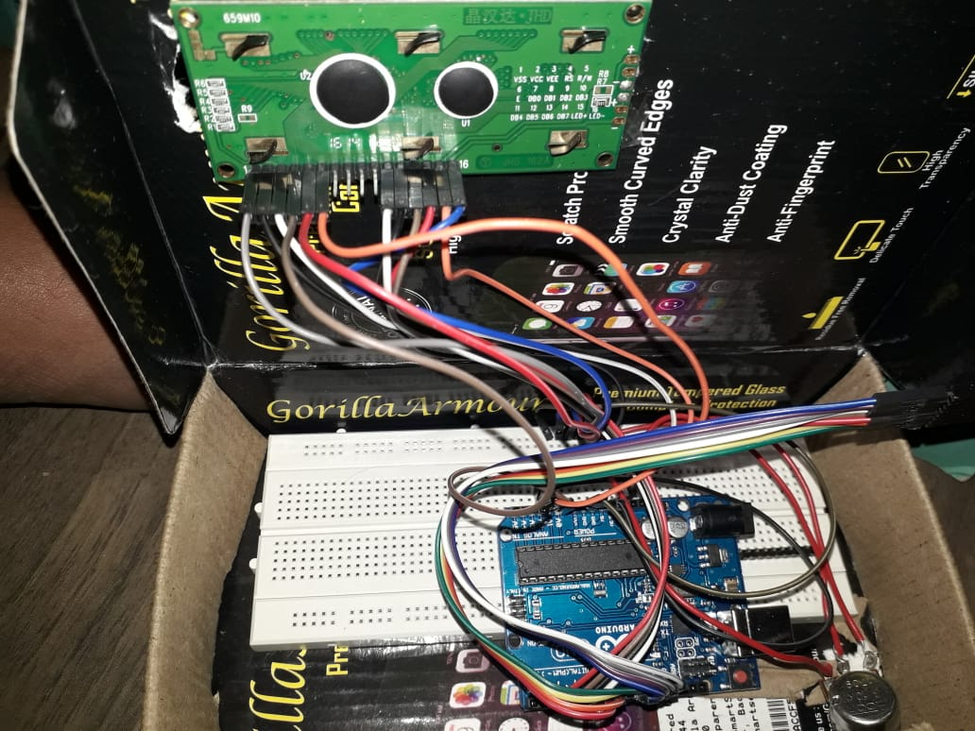

# Program Code

<https://github.com/gauraksh-garg/feedback-code.git>